**Project Design Phase-II**

**Data Flow Diagram & User Stories**

|  |  |
| --- | --- |
| Date | 14 October 2022 |
| Team ID | PNT2022TMID30308 |
| Project Name | Project – Real-time River Water Quality Monitoring and Control System |
| Maximum Marks | 4 Marks |

**Data Flow Diagrams:**

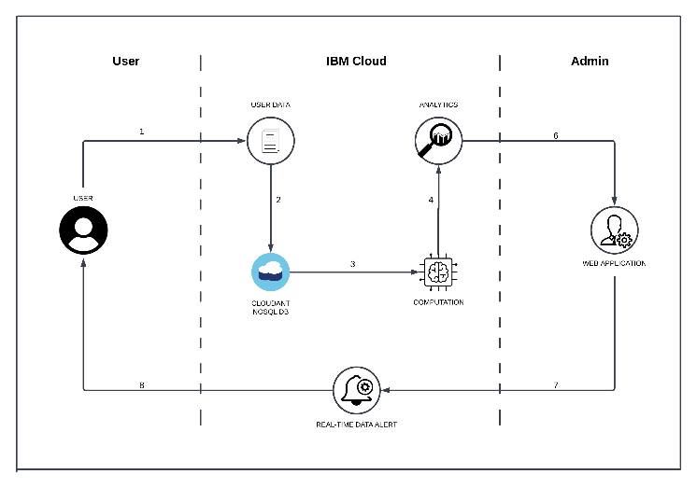

**User Stories**

|  |  |  |  |  |  |  |
| --- | --- | --- | --- | --- | --- | --- |
| **User Type** | **Functional Requirement (Epic)** | **User Story Number** | **User Story / Task** | **Acceptance criteria** | **Priority** | **Release** |
| Customer (Web user) | Registration | USN-1 | The user can register for the application by using their email, set password, and confirming their password. | Then User can create an account | High | Sprint-2 |
|  |  | USN-2 | After the registration then user will receive confirmation mail | The dashboard page will be displayed | High | Sprint-2 |
|  |  | USN-3 | The user can create account with their mobile number | The user access with their phone numbers their password | Low | Sprint-2 |
|  | Login | USN-4 | User can log in the application through their email or phone number and password | The user can access sensor data | Medium | Sprint-3 |
|  | Dashboard | USN-5 | After Login it shows the data in dashboard | Monitor the data level | Medium | Sprint-3 |
|  |  | USN-6 | When levels are abnormal it can send message to the user | application alert the user | High | Sprint-3 |
| Administrator |  |  | We provide the user exact sensor data of the river and alert abnormal characteristics if happen |  | High | Sprint-1 |